Maiden Bradley with Yarnfield Parish Council Members

Councillor Angus Neish Responsibilities – Chairman and Rights of Way Representative
Tel: 01985 844689
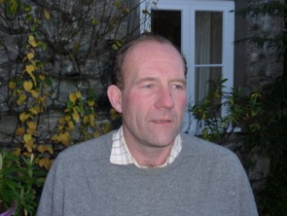

Councillor Patrick Nixon Responsibilities - Vice Chairman, Staffing Committee Chairman, Community Emergency Volunteer & Finance
Tel: 01985 844242


Councillor Ben Gunstone Responsibilities Staffing Committee Play Area Health & Safety
Tel: 01985844794



Councillor Sebastian Seymour Responsibilities – Village Design Statement Project

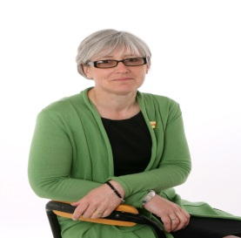
Councillor Susanna Brigden Responsibilities – Staffing Committee & Village Hall Representative


